CMPEN 472, Homework 10 CodeWarrior Full Chip Simulator (Debugger) Guide

For this Homework, you will need both the Terminal window and one 7-segment display and one DIL switch in VisualizationTool of the CodeWarrior Simulator, as shown below.

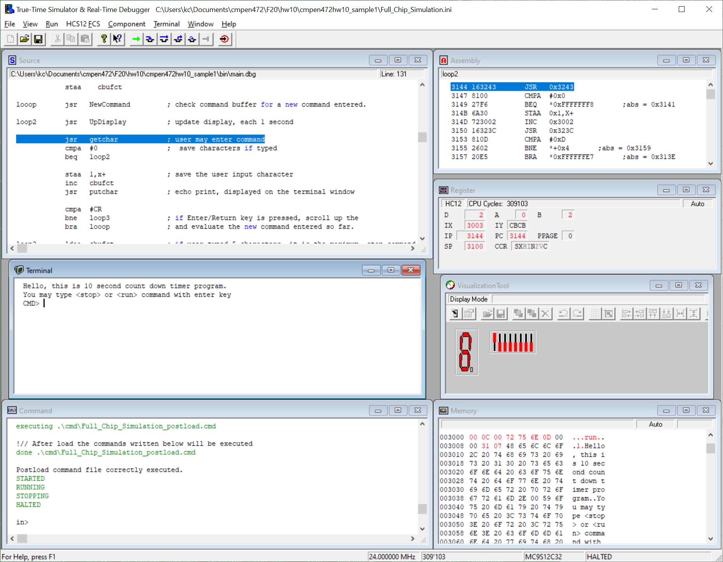

You may check the Homework 3 CodeWarrior Debugger/Simulator Aid. Also you may check the Homework 5 CodeWarrior Full Chip Simulator (Debugger) Guide, Step 3 – Terminal Component. Be sure to set the clock
at 24MHz, one 7-segment display attached to PORTB bit 4 to 7, one DIL switch attached to PORTB, and the VisualizationTool Cycle Refresh Count set to 1 CPU cycle. And save your simulator configuration. Then, close the debugger and restart the debugger.

For the Homework 10 sample/example program: While the program is running on the simulator, you will be able to see the LED blinking and also you may be able to type into the Terminal window. What you type is what you see. You may stop simulation by clicking the ‘Halt’ button on the Debugger window.

You may change the timer rate by (1) quit the Debugger. Then on your CodeWarrior window, (2)
change intct equ 7999 ; 125 usec * 8000 = 1.0 sec
to intct equ 79 ; 125 usec * 8000 = 1.0 sec
; my PC simulation works 79 => 1 sec approximately

Then (3) save your source file, and ‘Make’ and ‘Debug’

You may repeat this procedure to fine good speed as you debug your program.

How to save the Terminal screen text:
Click on the Terminal window. Then click on the ‘Terminal’ menu and select ‘Output File ...’ option. With this feature, you can save terminal communication into a text file, if you need. (You will need this feature for Homework 10.)

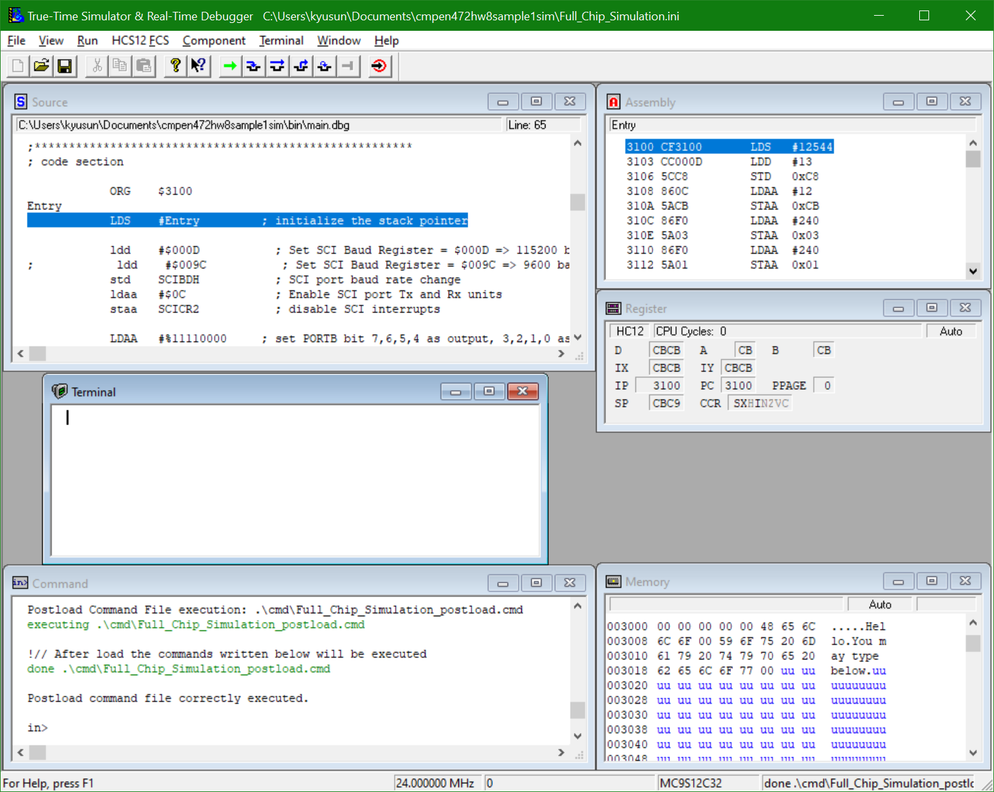

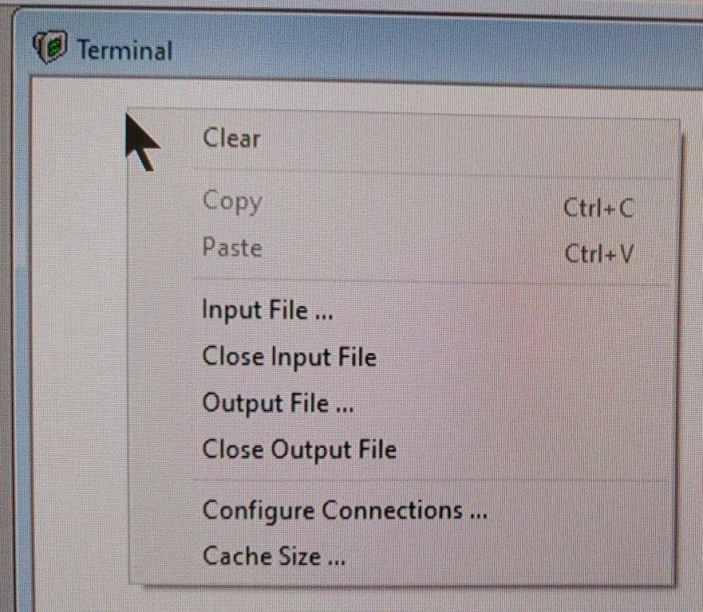

Type the file name, my default location for this text file is ‘Documents’ folder on my Windows PC.

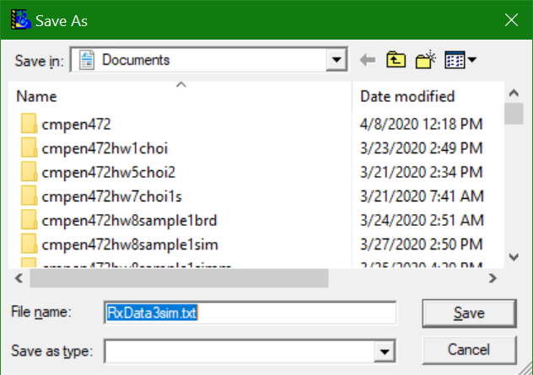

All of the text you see on the simulator Terminal will be saved in that file, ‘RxData3sim.txt’ in my case. If you have the file name ‘RxData3sim.txt’ in your folder, you will be asked to select ‘Overwrite’ or ‘Append’ option. Choose the one you like.

You MUST also select the ‘Close Output File’ menu in order to complete the file creation. Otherwise, you will not be able to see the file contents.

Another simulator Terminal option is the ‘Cache Size …’ This option allows you to set how many lines of text (maximum) you want to save into a text file. For Homework 10, you want to set 2000 or larger because one burst of analog-to-digital converter (ADC) data consists of 1024 lines.

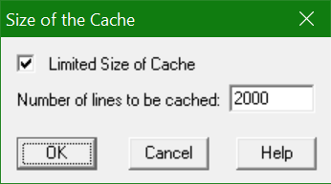

Click OK.

done

